Record/Upload a Media Assignment to a Course
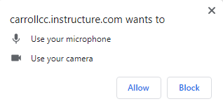
- Open the Assignment from its module.
- Click Start Assignment
- Click Record/Upload Media
- If you get a popup carrollcc.instructure.com wants to use your Microphone and/or camera, click Allow.
- Be default, the record tab is enabled. If you want to directly record, click Start Recording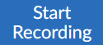
If you want to upload media, click the Upload Media tab and select either Audio or Video File then browse to where your file is saved.

