Print an Assignment Submission with Instructor Comments

If you would like to print an assignment you submitted with your instructor’s comments, do the following

- From the gradebook for your course, click the link to the assignment
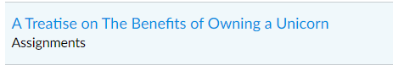
- Click View Feedback
- Click the download button to download a pdf of your submission
- Open the downloaded document in Acrobat (not the browser version)
- Click Tools > Comments
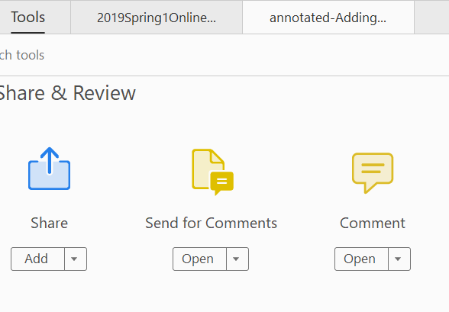
- A new pane will open on the right, showing your instructor’s comments
- Click the Print button
- Under Comments & Forms, select Document and Markups and click Summarize Comments
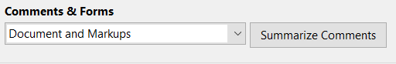
- Click Yes
- Your assignment will be printed with your instructor’s comments listed on separate pages.

