What Is Starfish and Where Can I Find It?

What is Starfish?
Starfish is Carroll Community College’s student retention alert system. It gives you a convenient way to keep track of your students and communicate with them and other offices on campus about how they are doing in your course. Starfish will automatically provide you access to all students that are enrolled in your courses. From there, you can raise flags about students, review flags that have been raised about your students, and provide additional information.
Raising flags when you observe a pattern of behavior that concerns you ensures that the people on campus who can intervene are aware. You’ll also have the ability to quickly offer important positive feedback, via kudos and messages. In addition to feedback about academic performance, Starfish can be used to refer students to services on campus like tutoring, their academic advisor, and Disability Support Services. These referrals send information about the service to students and alerts the service provider that a student could use their help.

Where can I find Starfish?
You can access Carroll’s Starfish system via the C3 portal, Canvas, and the My Carroll tab on the website.
C3 Portal:
A link to Starfish is in the list of applications on the right side of the C3 Portal screen.
Canvas:
A link to Starfish can be found in Canvas by clicking on the Account icon.
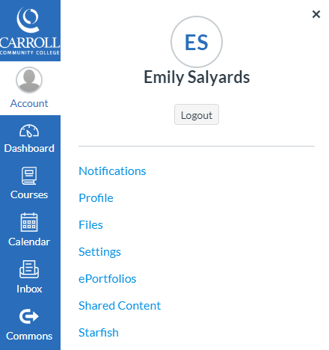

My Carroll:
On the main www.carrollcc.edu webpage, you can click on My Carroll at the top of the page.
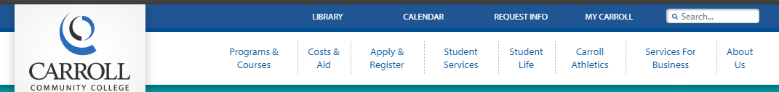

Then click on the Starfish icon.
